**New Laptop Configuration**

**Attach an asset tag to the bottom of the laptop and add to the asset register**

**Add a coloured dot to the side of the laptop and give the laptop a unique Laptop number**

**Turn on Laptop**

**Set the date and time**

**Connect the laptop the internet**

**Run Windows Update and install the updates**

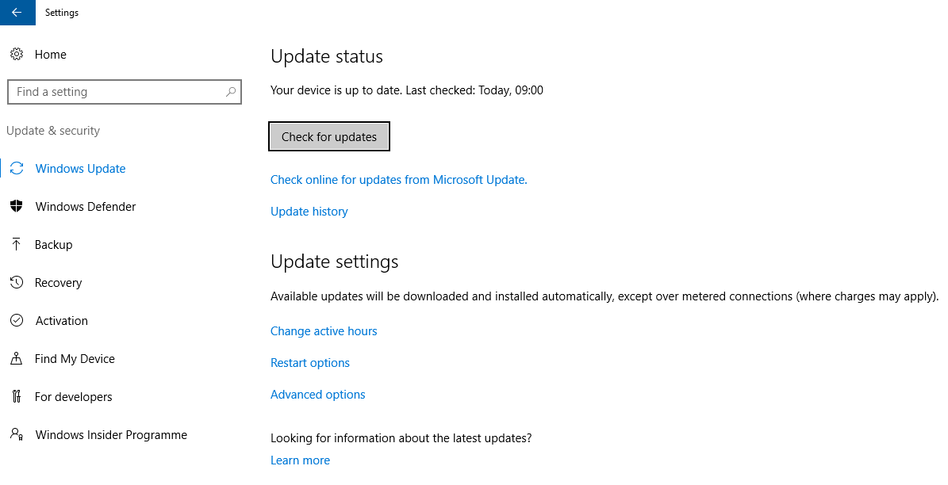

Note: This process may need to be ran 4 to 5 times to ensure everything is up to date.

Click on check for updates once Windows has finished searching then install the updates.

**Change power settings to stop the Screen Saver and Hibernation this can be found in:**

1. **Control Panel**
2. **System and Security**
3. **Power Options**

**Then click on Change plan settings**

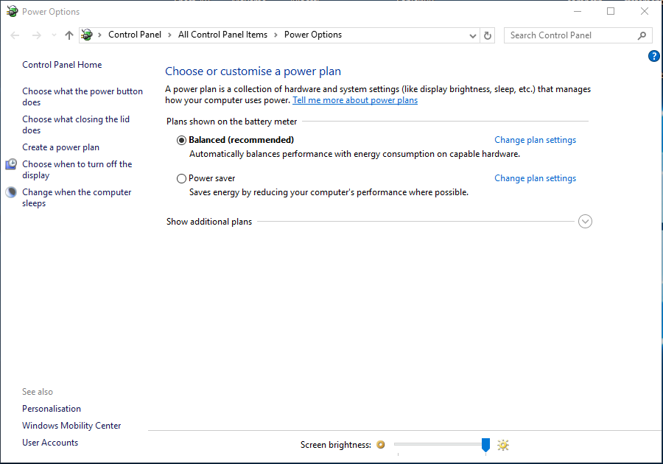

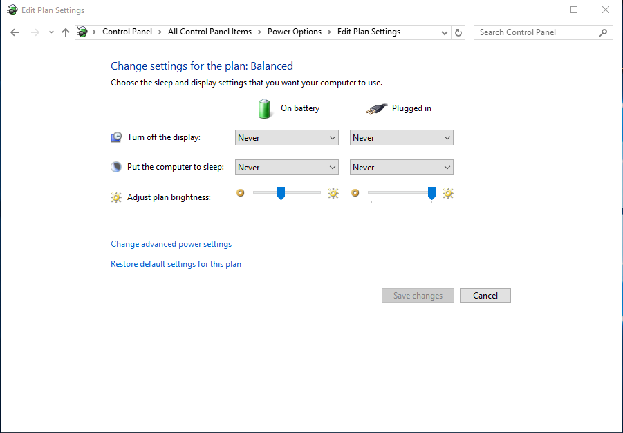

Then “Save Changes” to confirm

Next you will need to select Never in “all” of the drop downs

**Next change the “User Control Setting”**

1. **Control Panel**
2. **Users Accounts**

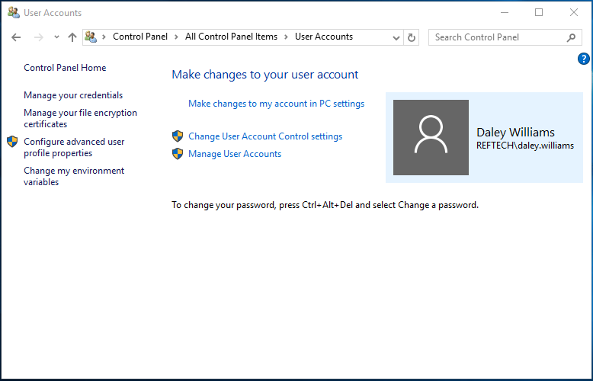

Click “Change User Account Control Settings”

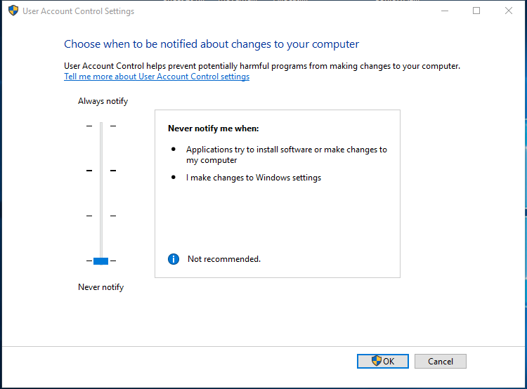

Click “OK”

Then set the Notification Bar to “Never Notify”